**PROJECT 1.**

**VIRTUAL KEY FOR YOUR REPOSITORIES**

**1] Project and Developer Details / Welcome Screen.**

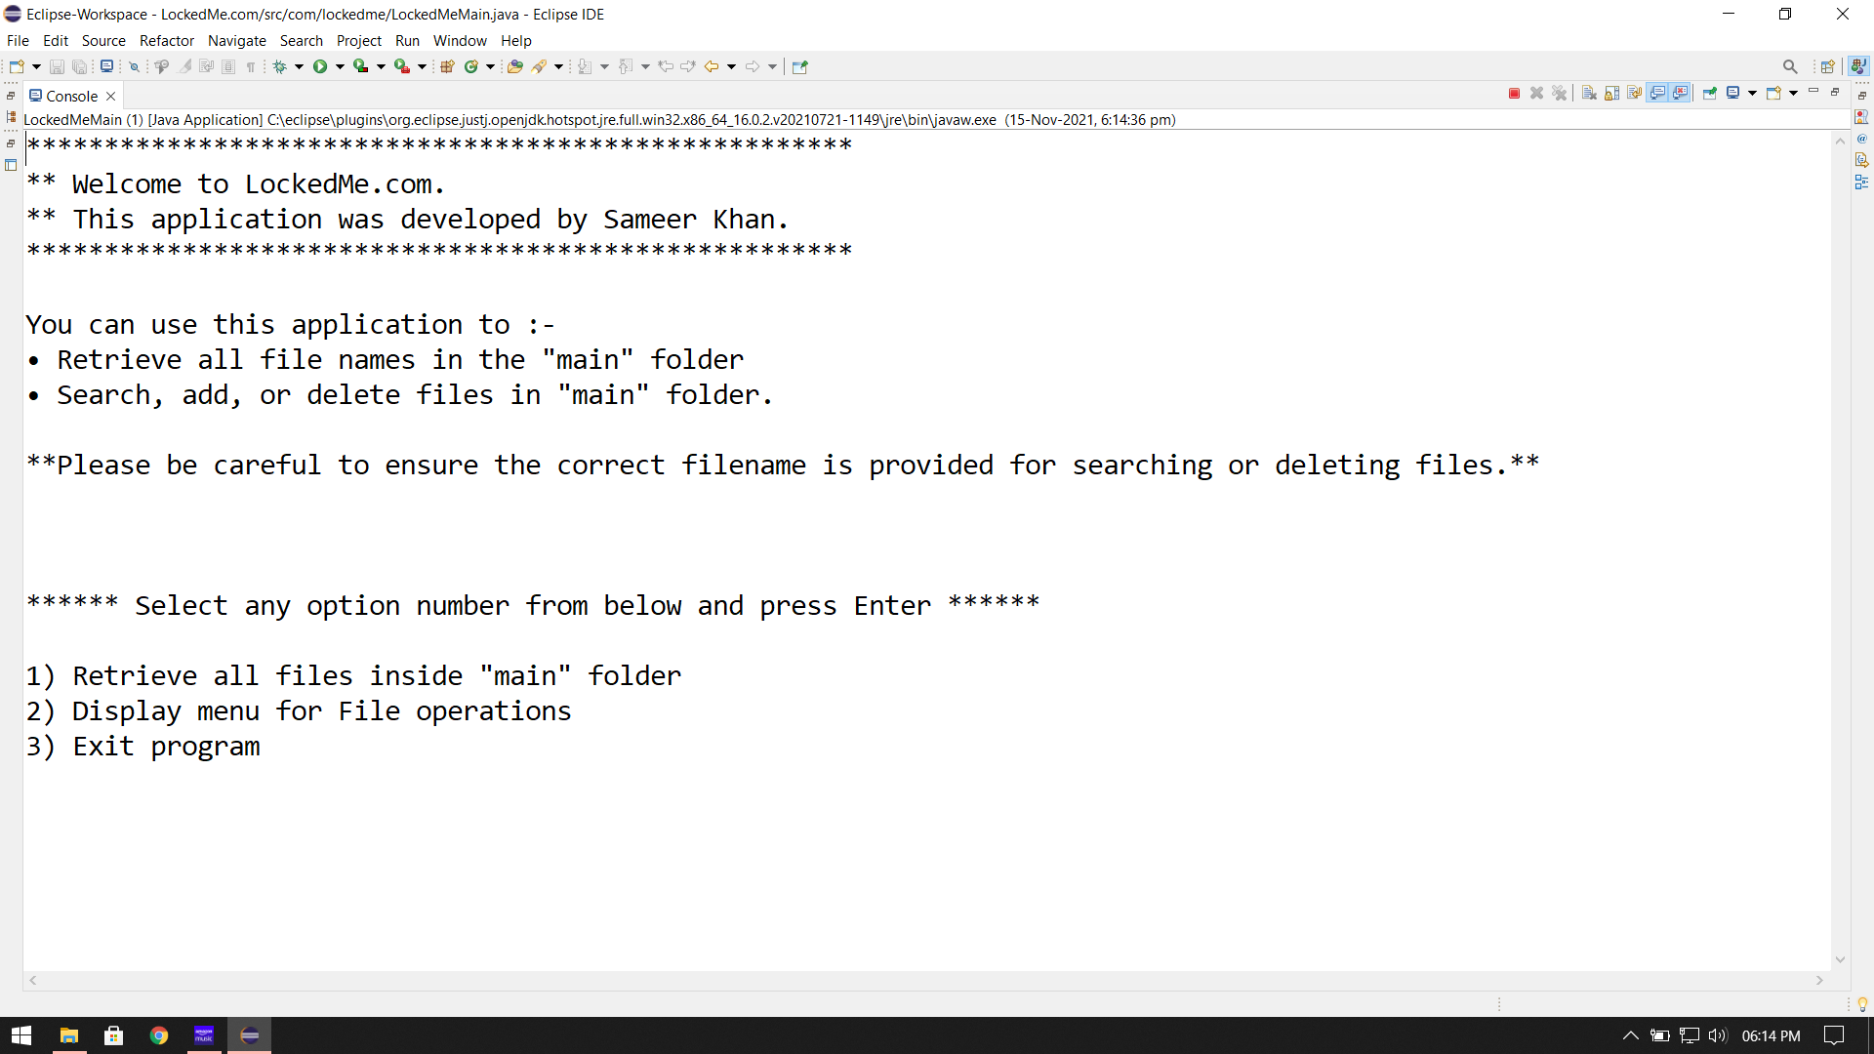

**2] The First Option Returning the Current File Names In Ascending Order.**

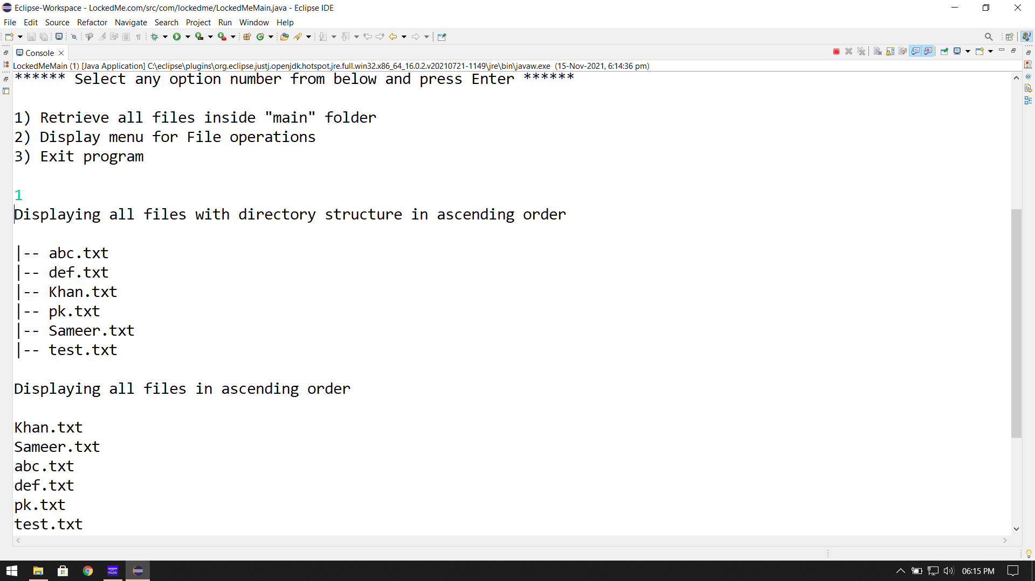

**3]** **The Second Option Returning the Details of The User Interface.**

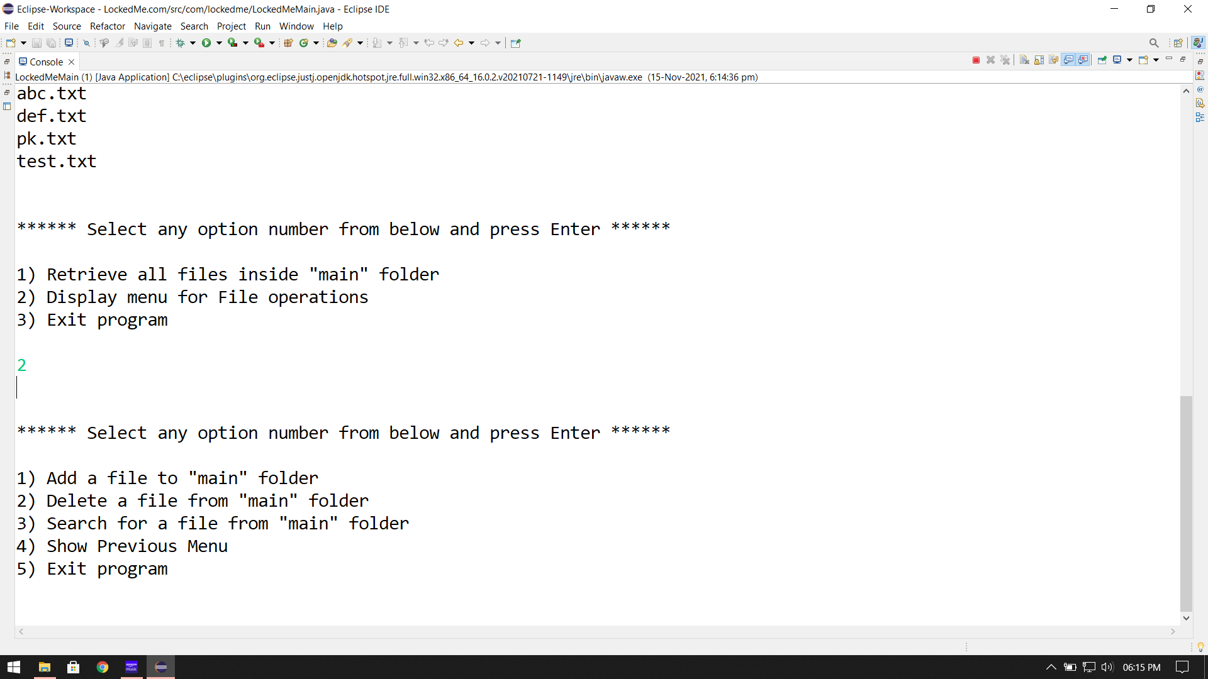

**4] Add A File to The Existing Directory List.**

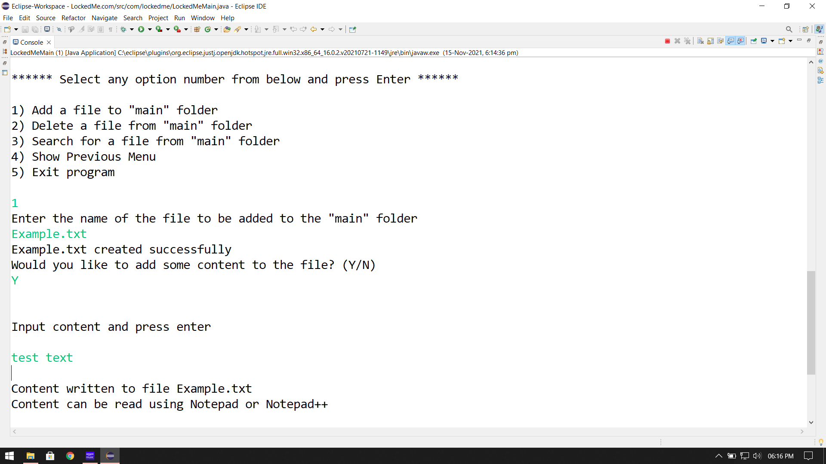

**5] Delete A User Specified File from The Existing Directory List.**

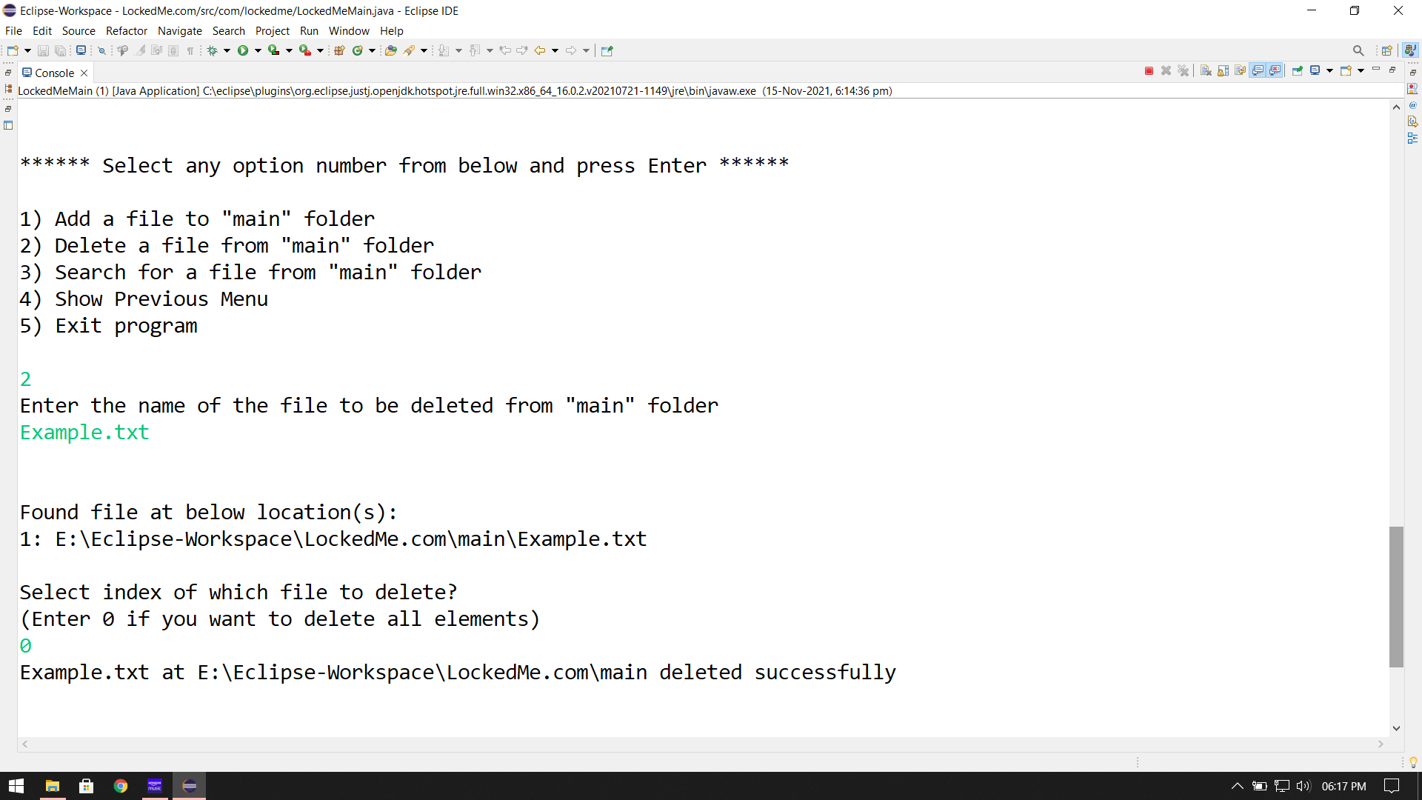

**6]** **Search A User Specified File from The Main Directory.**

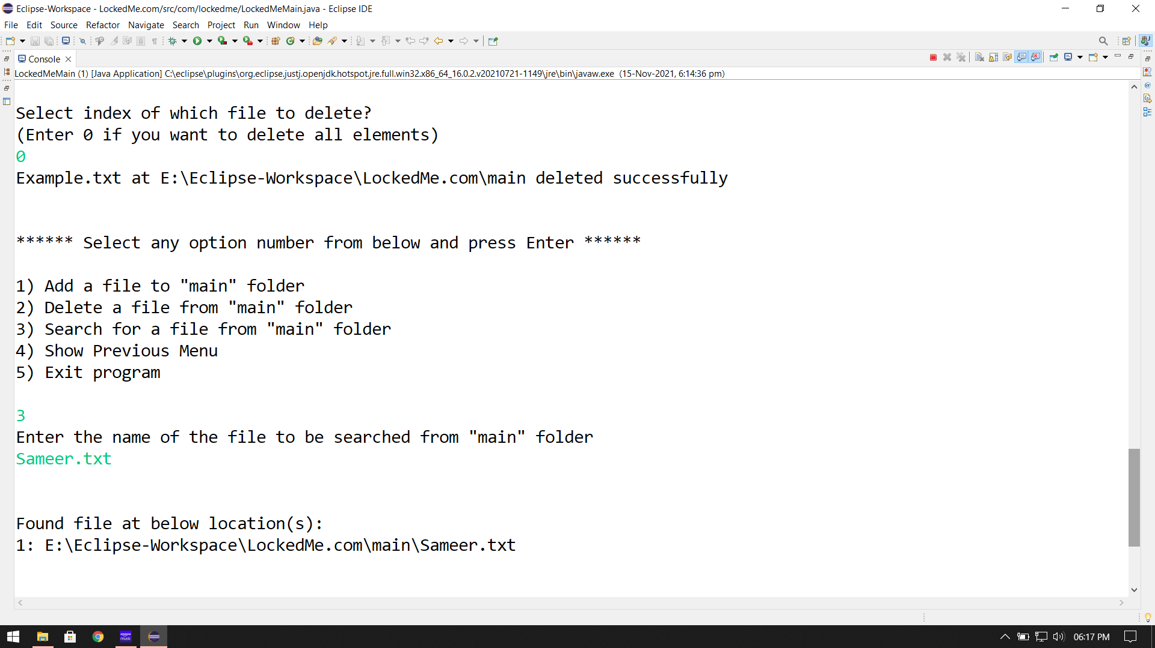

**7] Show Previous Menu.**

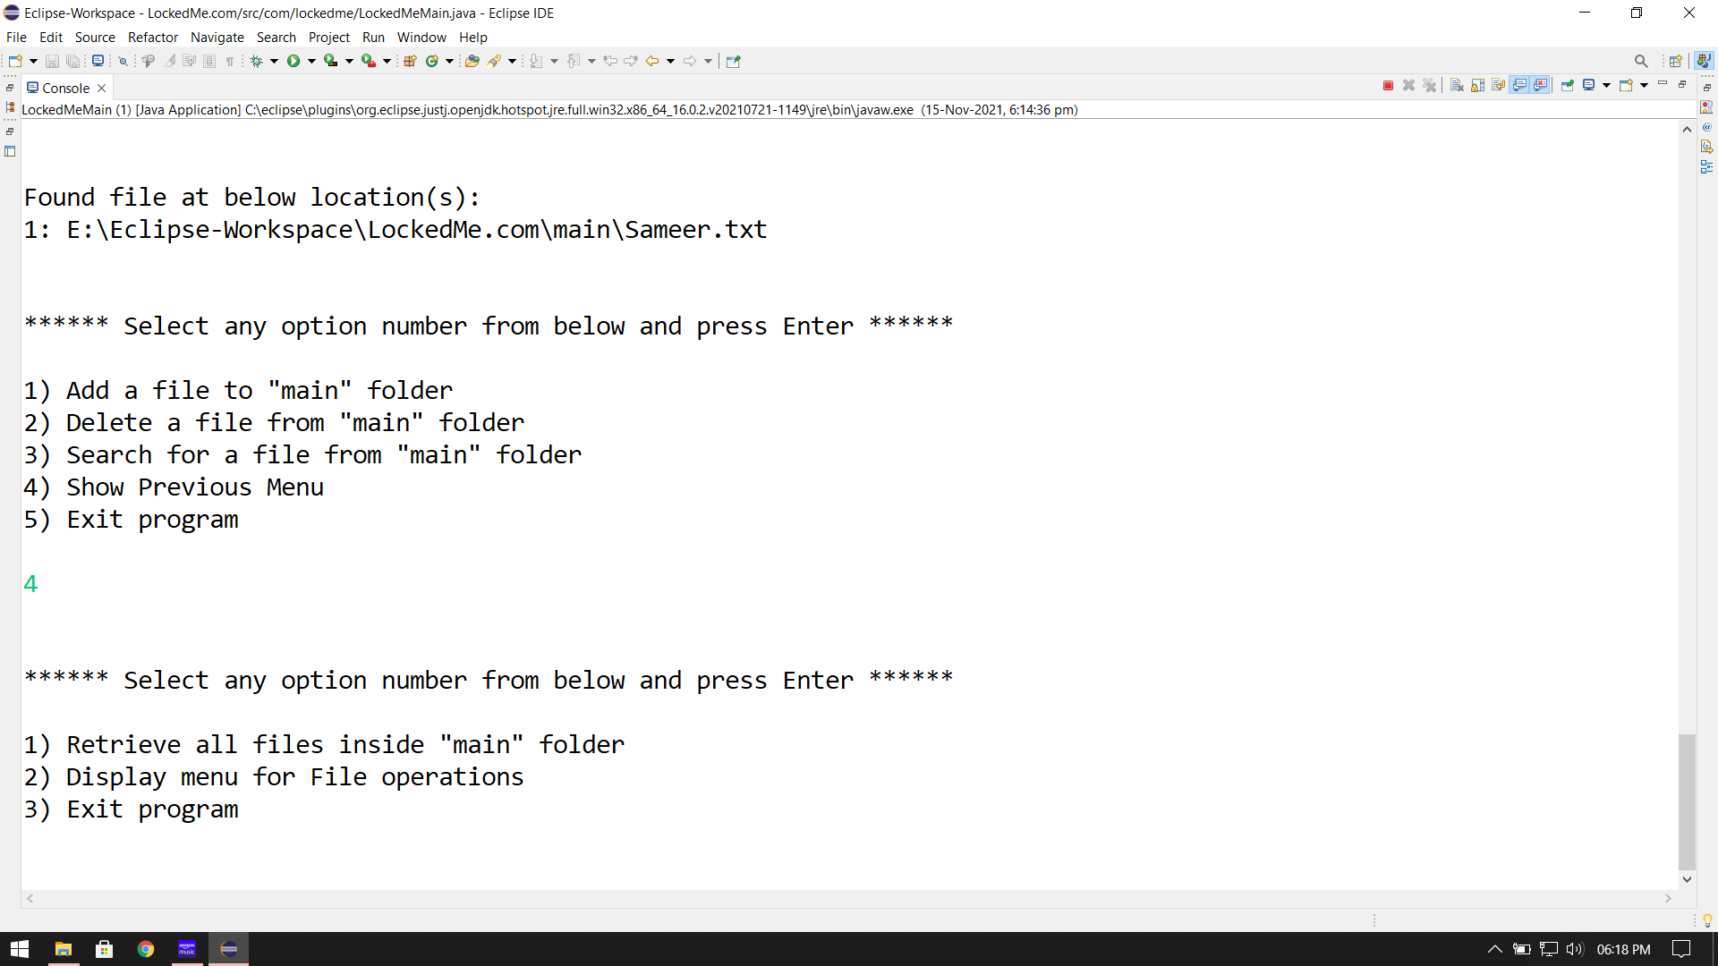

**8] Exit Program.**

